**Instructions:**Replace **[bracketed red text]** with the requested information or screen capture.  
Replace **bracketed red text with black text**.  
**PLEASE do not include full page, full window screen shot images**, or full screen shots that have been reduced in size.

Please do not work the assignment and the tutorial at the same time.   
  
Use a snippet tool to capture parts of the screen and insert those images into the template.  
**Do not remove tags from this template. An example of a tag is [C01]. All fields are required.***Please do not alter template formatting or delete parts of this template.*

Part A - Student Information:   
1. Student Name: [STUDENT NAME – Aamir, Patel] [A.1]  
2. Student email: [Student Email: - [Aamir8567@gmail.com](mailto:Aamir8567@gmail.com) ] [A.2]  
3. Student Phone: [Student Phone: - (872) 985 - 4361] [A.3] OPTIONALGo back to the instructions and continue with Part B.Part B - Review Drupal versions:

1. What core version(s) of Drupal will we use in this class, Drupal 6.x, 7.x, 8.x, or 9.x?  
   [B.1] [ Drupal 9.x]
2. List the reasons we can or cannot install the module listed below a Drupal 8 or Drupal 9 site?  
   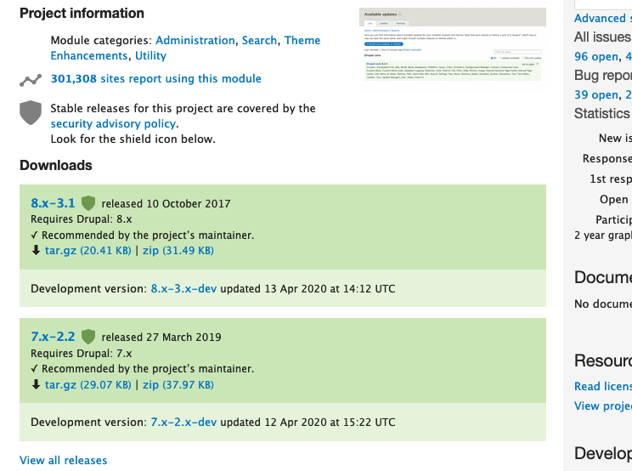  
   [B.2.1] [ We can not install this module because it does not support Drupal 9. We can tell by there being no ^ sign before the version.]  
   [B.2.2] [ Another reason why we can not download this version is because it does not mention anything related to drupal 9 either. ]
3. List the reasons we can or cannot install the module listed below on a Drupal 9 site?  
   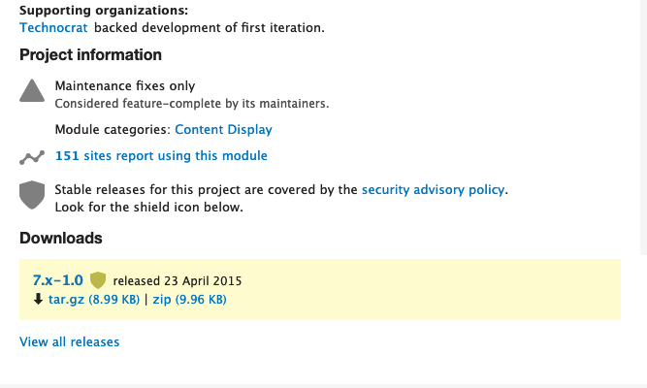  
   [B.3] [ We can not install this either because it does not mention anything about supported versions, or any version at all. Plus it was released in 2015.]
4. List the reasons we can or cannot install the module listed below on a Drupal 9 site?  
   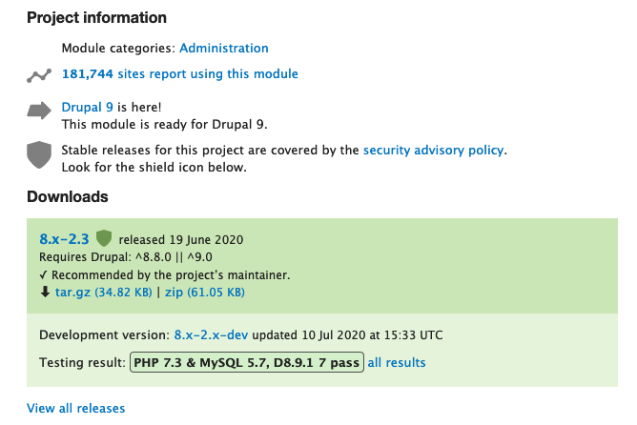  
   [B.4] [We can install this module, because it says it is ready for Drupal 9, and it also mentions/confirms that in the Requires Drupal version by saying, ^8.8.0 ||(or) ^9.0. ]

Part C – Drupal CMS Website and Web Host Information:   
 **Part C.1 – Drupal 9 on a Shared web host**

1. Enter the following shared web host Drupal site information **[C.1]**
   1. Shared Web Host Company Name: [ Namecheap ]
   2. Shared Web Host URL: [ Namecheap.com ]
   3. Shared Web Host account username: [ aamir8567 ]
   4. Shared Web Host password: [ Kamboli90123! ]
   5. Website Admin Username: [ aapadcpate ]
   6. Website Admin Password: [ 9aIwR@LZB%#uk9Fgh3]
   7. Database Name: [ drup438 ]
   8. Table Prefix: [ dr8x_ ]
   9. Website URL: [ <http://aamirpatel.tech/tutorial07/> ]

**Part C.2 – Drupal 8 (or Drupal 9) on Pantheon (PaaS)**

1. Enter the following shared web host Drupal site information **[C.2]**
   1. PaaS Drupal version: [ Drupal 8 or Drupal 9]  
      PaaS Drupal 9 Front end site URL: [ website URL here ]
   2. PaaS Drupal 9 site Admin Username: [ website admin username here ]
   3. PaaS Drupal 9 site Admin Password: [ website admin password here ]

**Part C.3 – Drupal 9 on Acquia Dev Desktop**

1. Enter the following Acquia Dev Desktop web host Drupal 9 site information **[C.3.1]**
   1. Drupal major.minor.patch version built: [ Drupal version here ]
   2. **Site name:** [site name here]
   3. **Site email address:** [email address here]
   4. **Site Username:** [website username here]
   5. **Site Password:** [website password here ]
2. **Screen capture of the Acquia Dev Desktop Drupal 9 Project Settings Block**[C.3.2]   
   [SCREEN CAPTURE HERE]

**Part C.4 – Drupal 9 on Codeanywhere**

1. Enter the following Codeanywhere web host Drupal 9 site information **[C.4]**
   1. Codeanywhere account username(email): [ mpate180@depaul.edu]
   2. Codeanywhere account password: [ Kamboli1!]
   3. Drupal version built (version.minor.patch): [ 9.1.4 ]
   4. Site Title: [ AP – Tutorial 07 ]
   5. Website Username: [ aapadcpate ]
   6. Website Password: [ 9aIwR@LZB%#uk9Fgh3]

**Go back to the tutorial instructions and begin working on Part D.**

Part D – The Drupal 9 Administration Toolbars Review

1. Drupal backend has two admin toolbars named toolbar and shortcut. List one difference between them.  
   [D.1]  
   [ Toolbar comes when you select Manage and it has all of the settings that Drupal supports. While Shortcut also brings a toolbar, but it only has settings that you have put a star on, meaning it shows the ones that you have selected to be your favorites.]
2. What admin toolbar options do you select to set module permissions?  
   [D.2]  
   [ For module permissions you select Configuration.]
3. What toolbar options do you select to change the front end or admin theme?  
   [D.3]  
   [ To change Frontend or Backend theme you select Appearance. ]
4. What toolbar options do you select to extend the Drupal site with modules?  
   [D.4]  
   [ To extend Drupal site with modules/plugins you select Extend.]
5. What is the purpose of the Mange link on the admin toolbar?  
   [D.5]  
   [ The manage link on Admin Toolbar allows you to go to all the available settings you have and can do for your Drupal site.]

Part E – Extending Drupal through Themes

Install and set

1. SCREEN CAPTURE – Backend Admin toolbar > Appearance (top of the page) with the default theme visible ( Installed themes)  
   [E.1]   
   [ 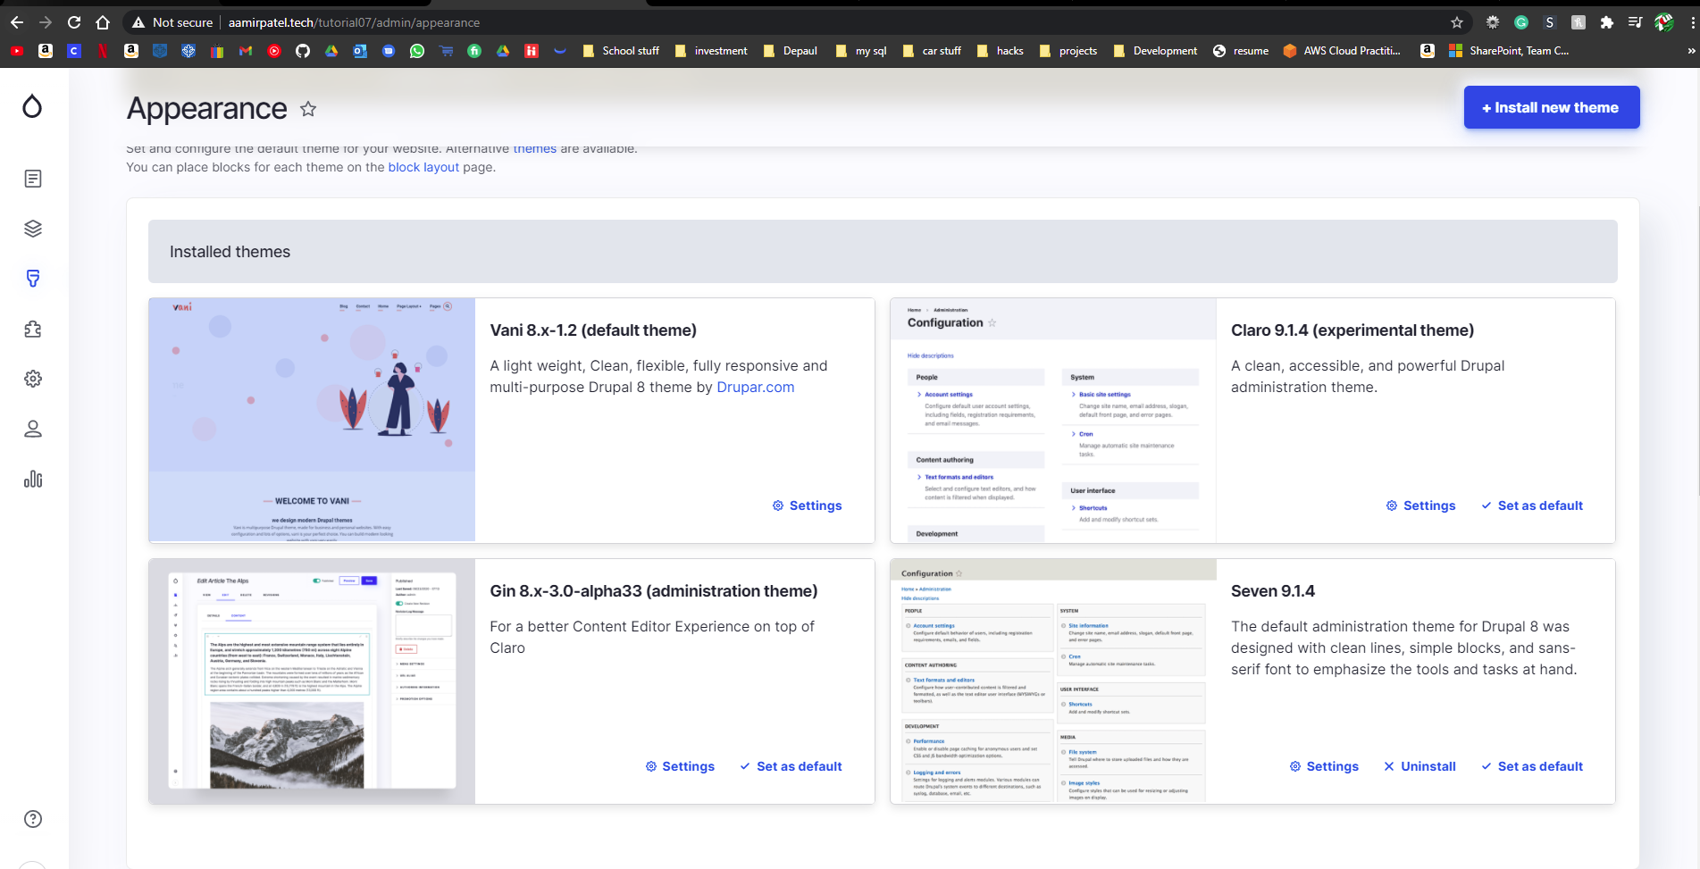 ]
2. SCREEN CAPTURE – Backend Admin toolbar > Appearance (bottom of the page) with the ADMINISTRATION THEME dropdown control visible (Admin theme)  
   [E.2]   
   [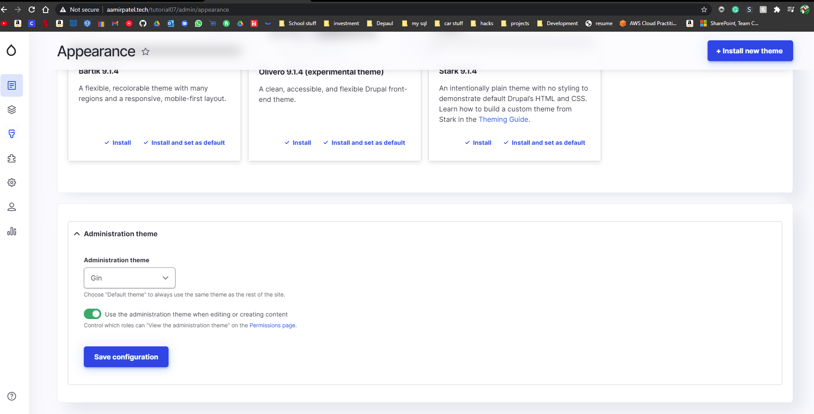 ]
3. SCREEN CAPTURE – Backend Admin toolbar > Appearance, Vani theme settings   
   [E.3]   
   [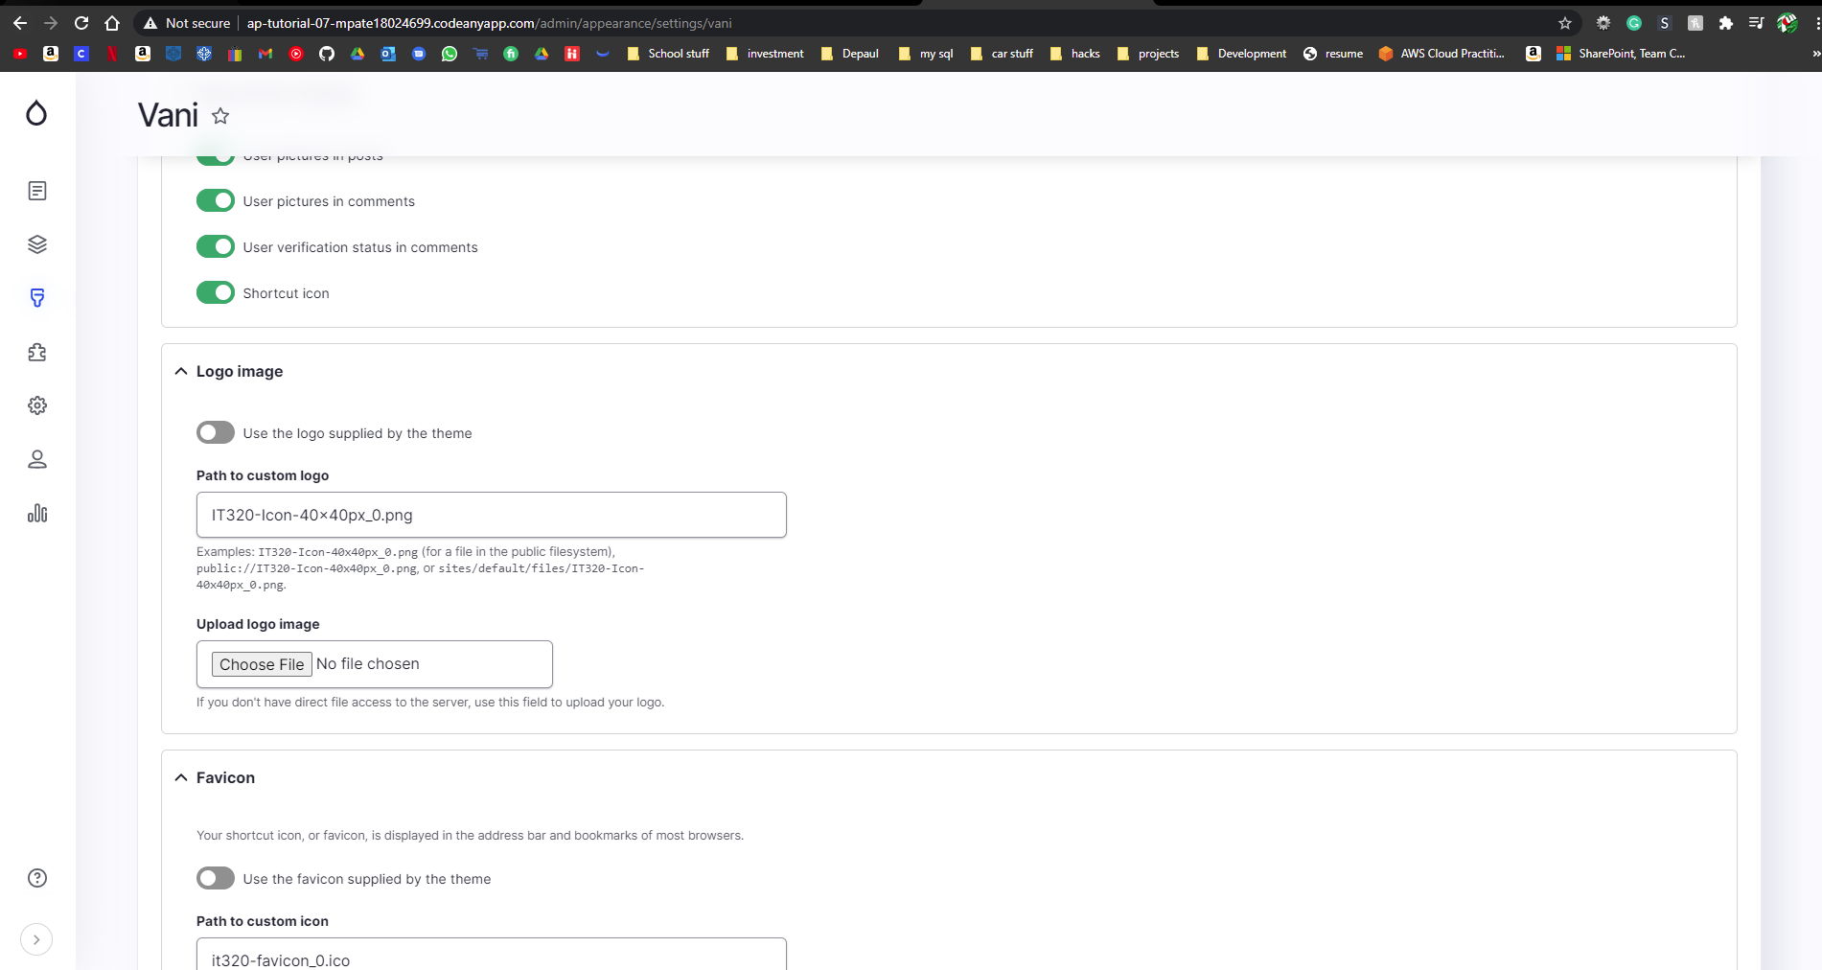]
4. SCREEN CAPTURE – front-end home page of the website with the web browser TABs (favion) and the web browser address bar visible and readable  
   [E.4]   
   [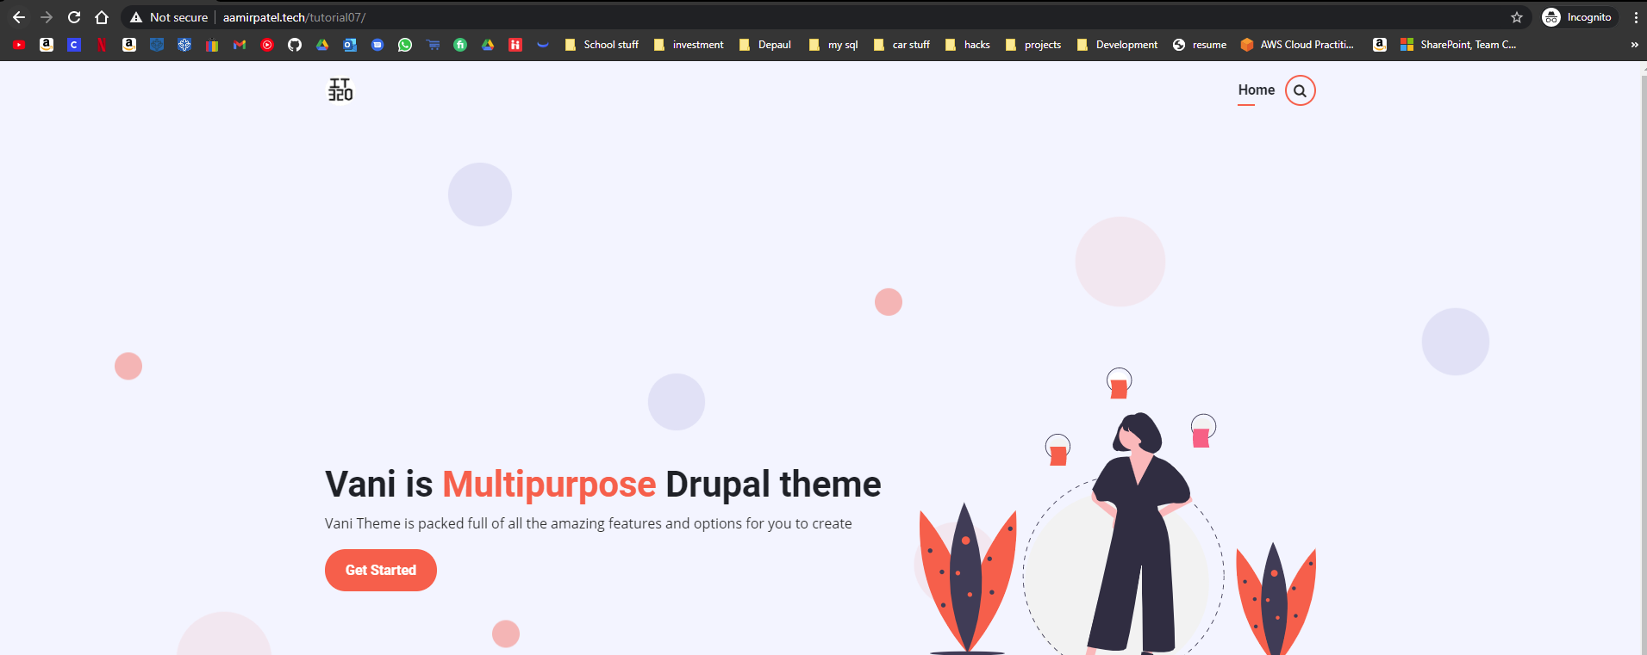]
5. Go back to the tutorial and begin working on Part F.

Part F – Drupal 9 Basic pages

Shared Web Host, Pantheon or Localhost Drupal 9 Screen Captures:

1. SCREEN CAPTURE – Backend List of Basic Page nodes you created  
   Admin toolbar > Content, Filter content by Basic page before taking screen capture[F.1]   
   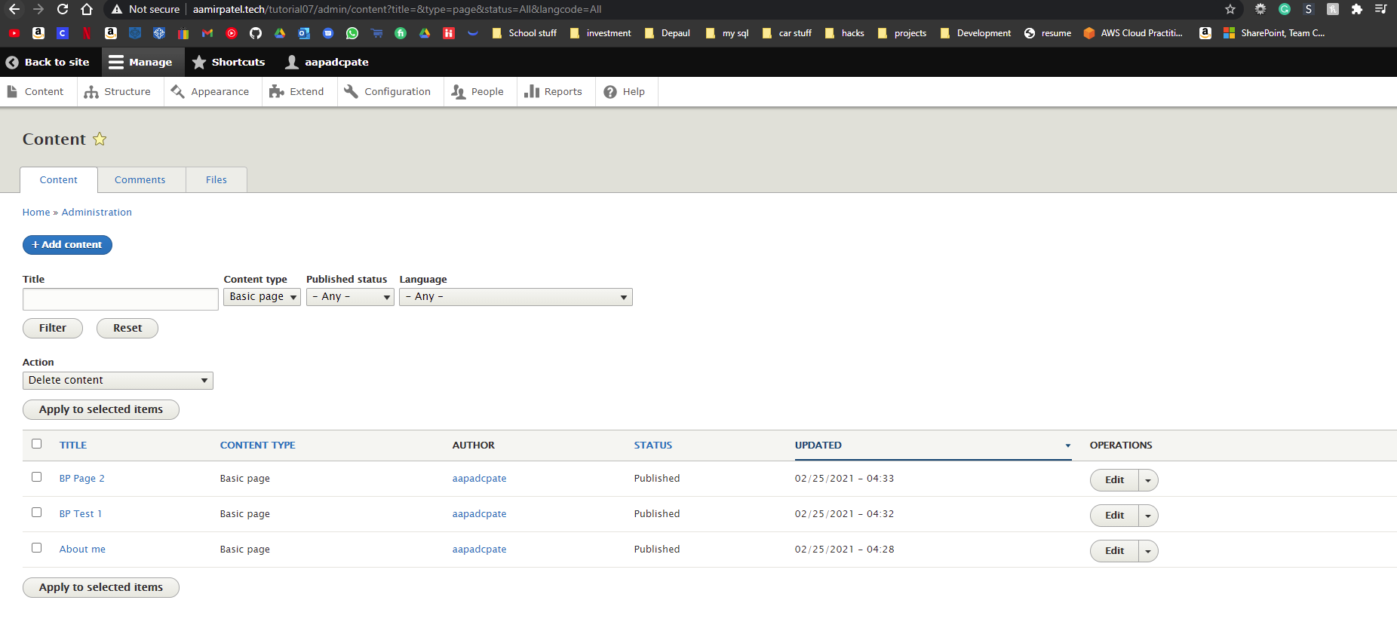]
2. SCREEN CAPTURE – Backend – Edit the Basic Page “BP Test 1” and take a screen capture of the Backend edit template.  
   NOTE: Increase your web browser page width to see the entire Basic page edit template or press the COG icon (see image below). If the screen width is to narrow, the right-side block (Published, menu Settings, URL Alias, Authoring Information, and Promotion Options) is hidden.

[F.2]  
 [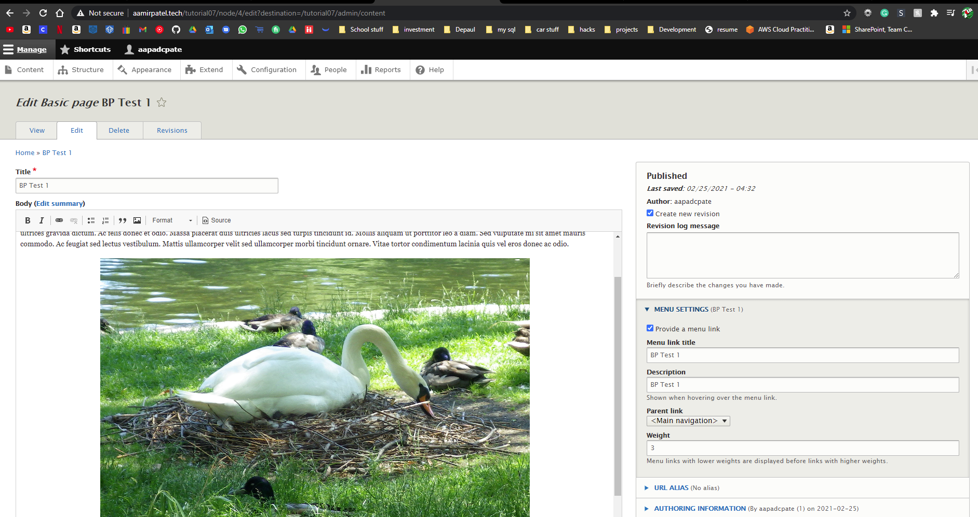]

1. SCREEN CAPTURE – Frontend screen capture of the Basic Page “BP Test 1”.  
   Note: Frontend means a web browser where you are not logged into the Drupal site.  
   Please make sure the web browser address bar is visible on your screen capture.   
   [F.3]   
   [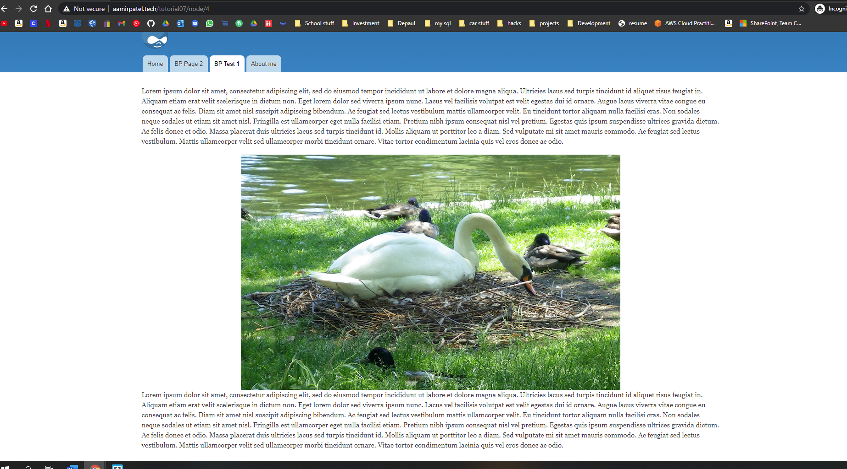]

Go back to the instructions and continue with Part G.

Part G – Drupal 9 – Menu Management

1. SCREEN CAPTURE – Backend Admin toolbar > Structure > Menus > Main navigation selecting Edit Menu.  
If Drag and Drop is not enabled, please select (click) “Hide row weights” then take the capture.  
[G.1]   
[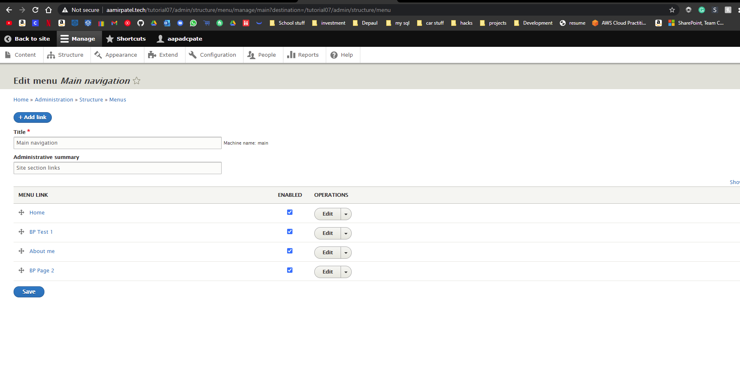]

3. SCREEN CAPTURE – Front end website showing the main menu  
[G.2]   
[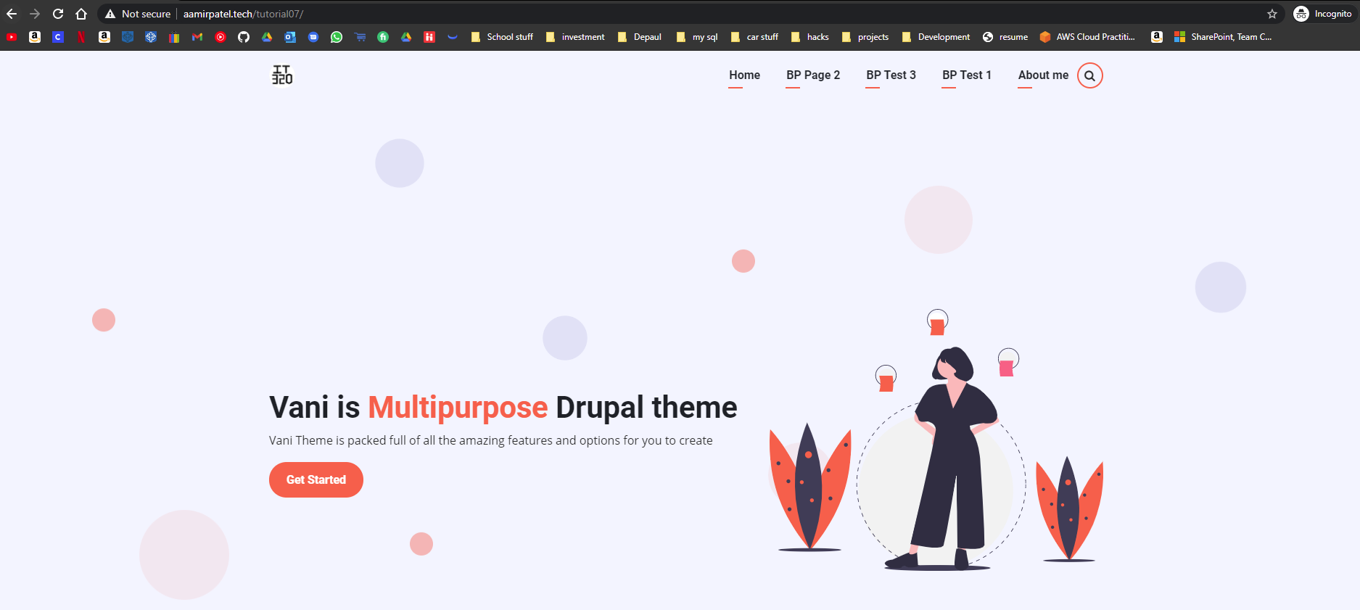]

Go back to the instructions and continue with Part H.

Part H – Drupal 9 – Creating Article Content Nodes (Codeanywhere)

**\* Switch over and start using your Codeanywhere Drupal 9 site.**

1. **Codeanywhere** SCREEN CAPTURE – Backend List of Article nodes you created  
   Admin toolbar > Content, Filter content by Article before taking screen capture[H.1]   
   [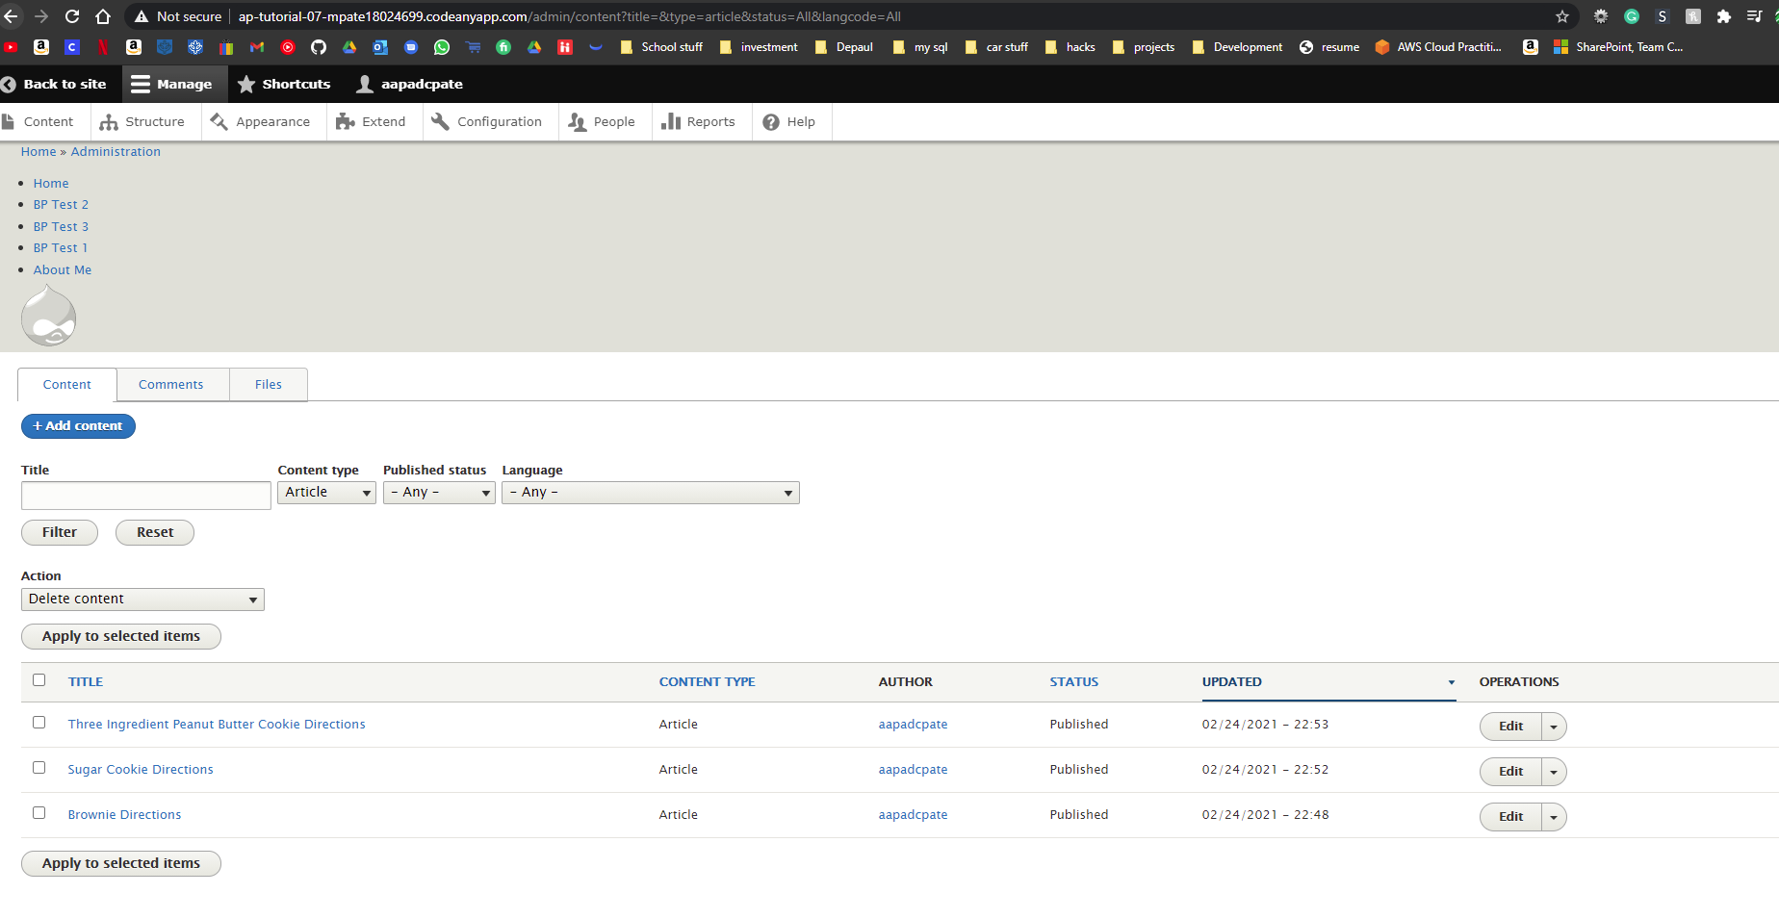]
2. **Codeanywhere -** SCREEN CAPTURE – Backend Article nodes Title and Tags  
   Edit an Article you created and take a screen capture the top title, tags [H.2]   
   [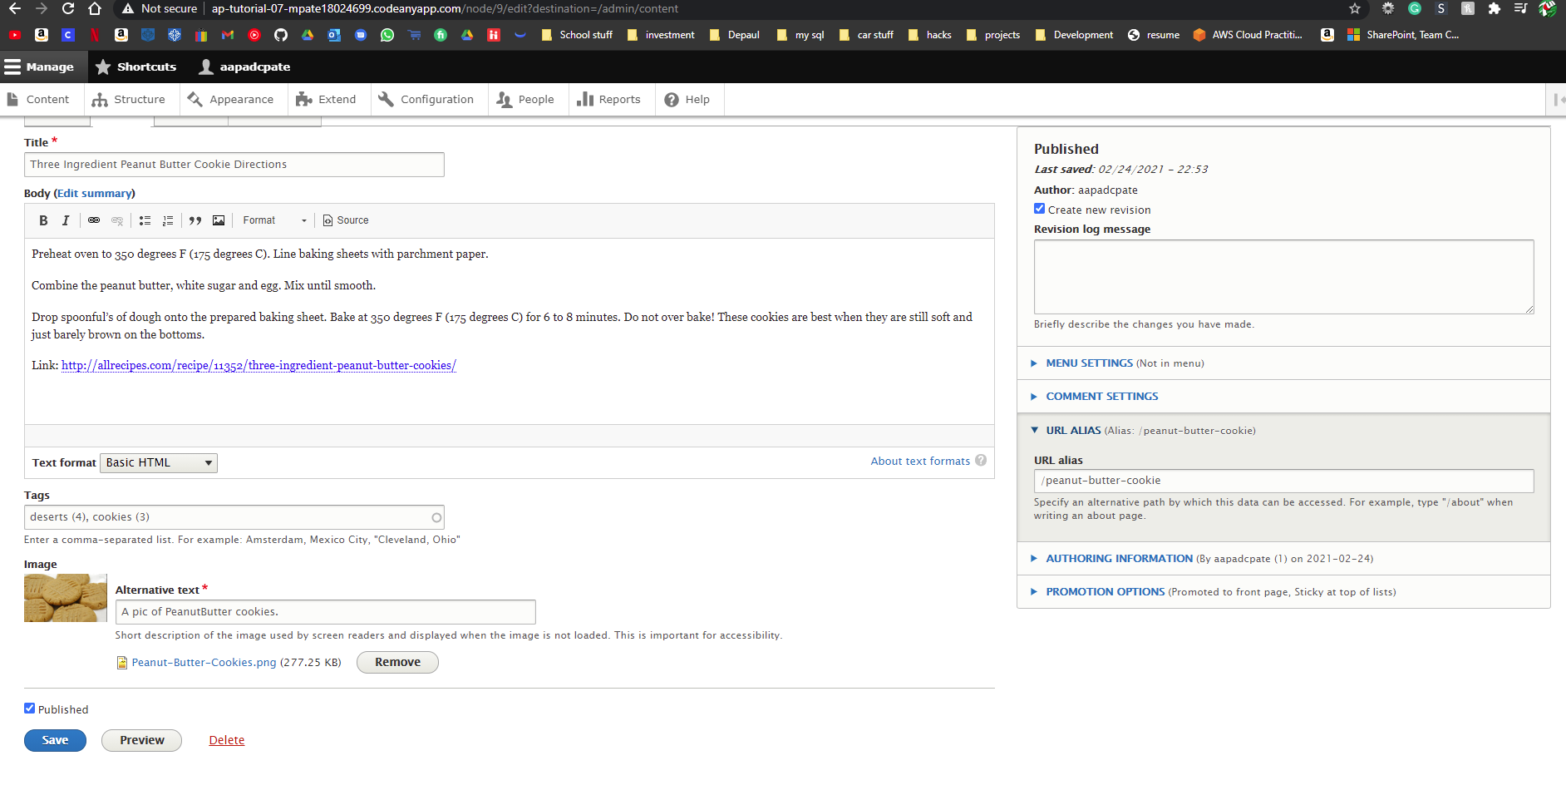]
3. **Codeanywhere -**SCREEN CAPTURE – Backend Article nodes Body and Blocks  
   Edit an Article you created and take a screen capture the body and side blocks   
   Show (1-9) see image below:  
   [H.3]   
   [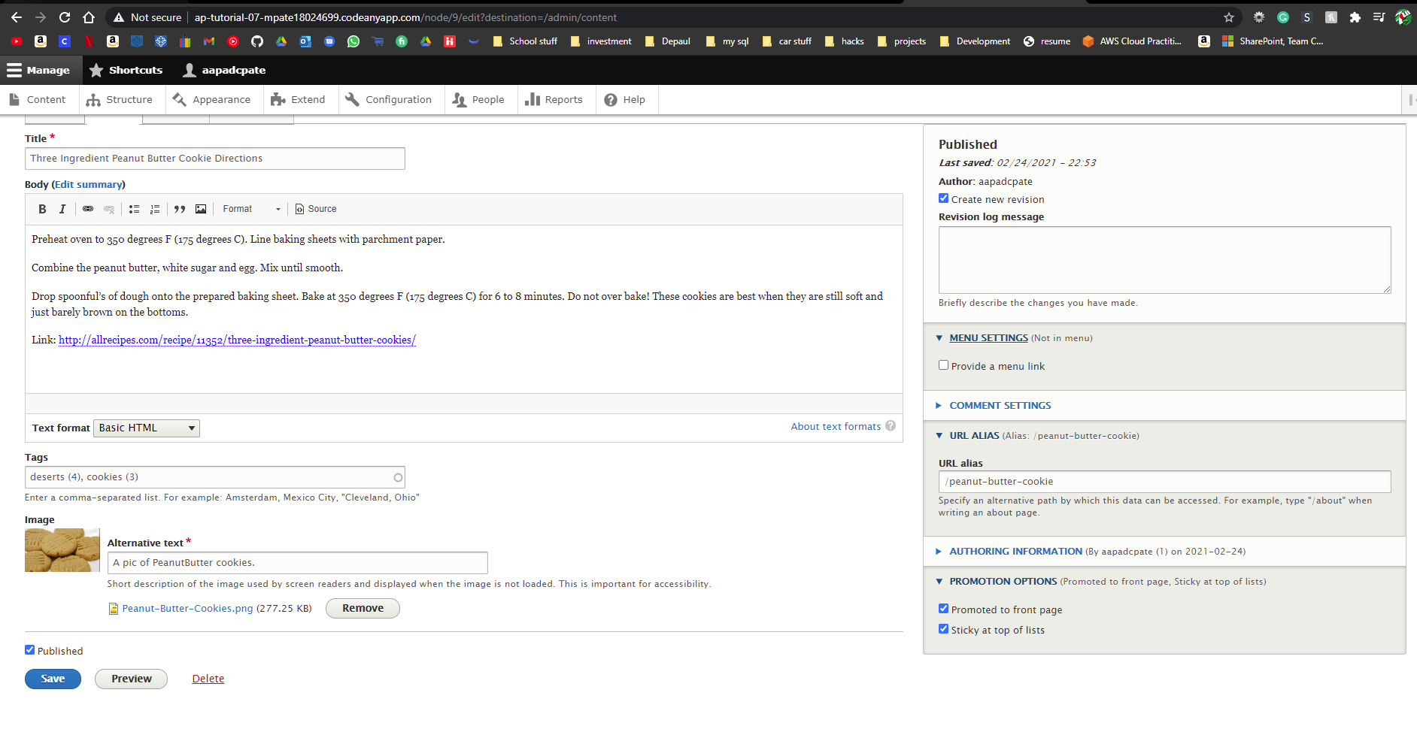]
4. **Codeanywhere -** SCREEN CAPTURE – Front end Article   
   Note: Frontend means a web browser where you are not logged into the Drupal site.[H.4]   
   [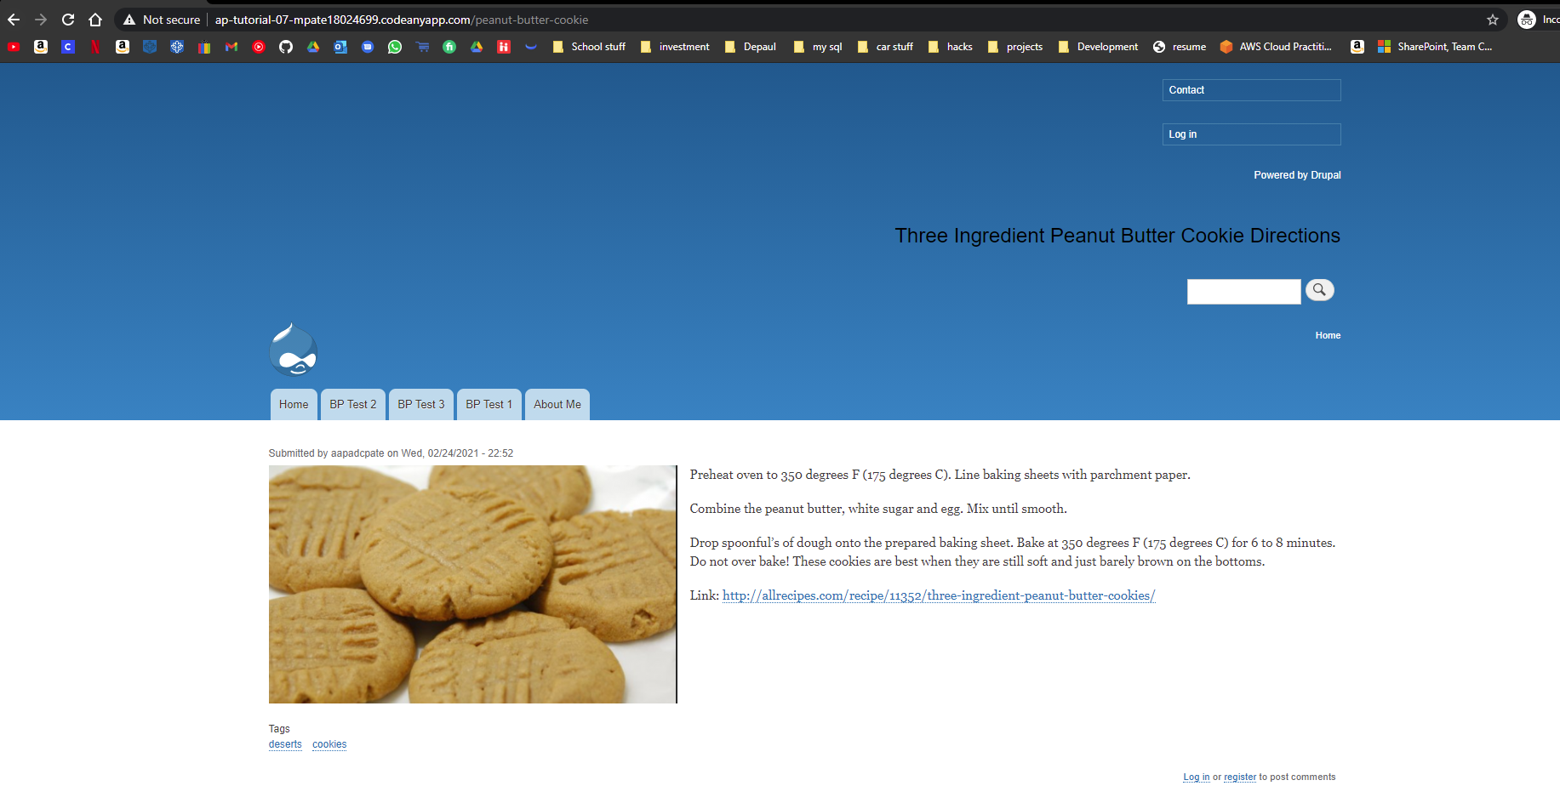]

Go back to the instructions and continue with Part I.

Part I - Hardening a Drupal 9 site (All Platforms)

Which Platforms did you create Drupal sites on?  
[I.0.0]   
[ Shared Web Host (Namecheap)

CodeAnyWhere

]

On Shared Web Host:

1. SCREEN CAPTURE – Backend Admin toolbar > Configuration > REGISTRATION AND CANCELATION >> Who can register accounts?   
   [I.1.01]  
   [ 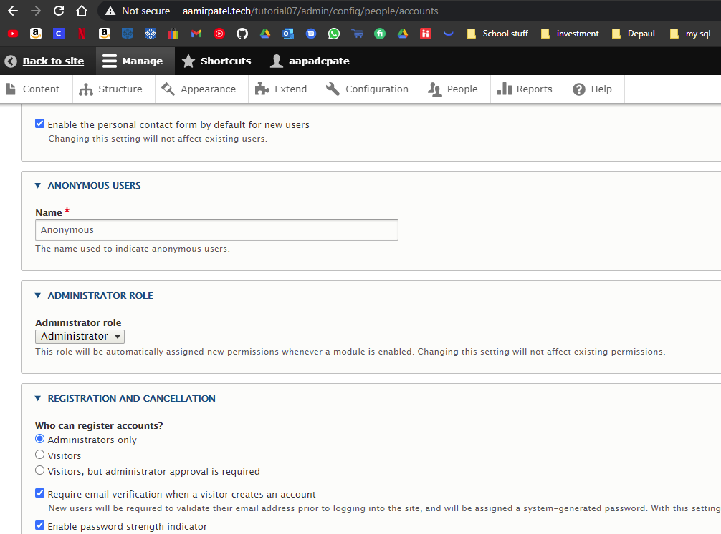 ]
2. Website frontend home page, then select the Login link. Please make sure the web browser address bar visible. This capture should show the login page missing the “Create new account” tab   
   [I.1.02]  
   [ 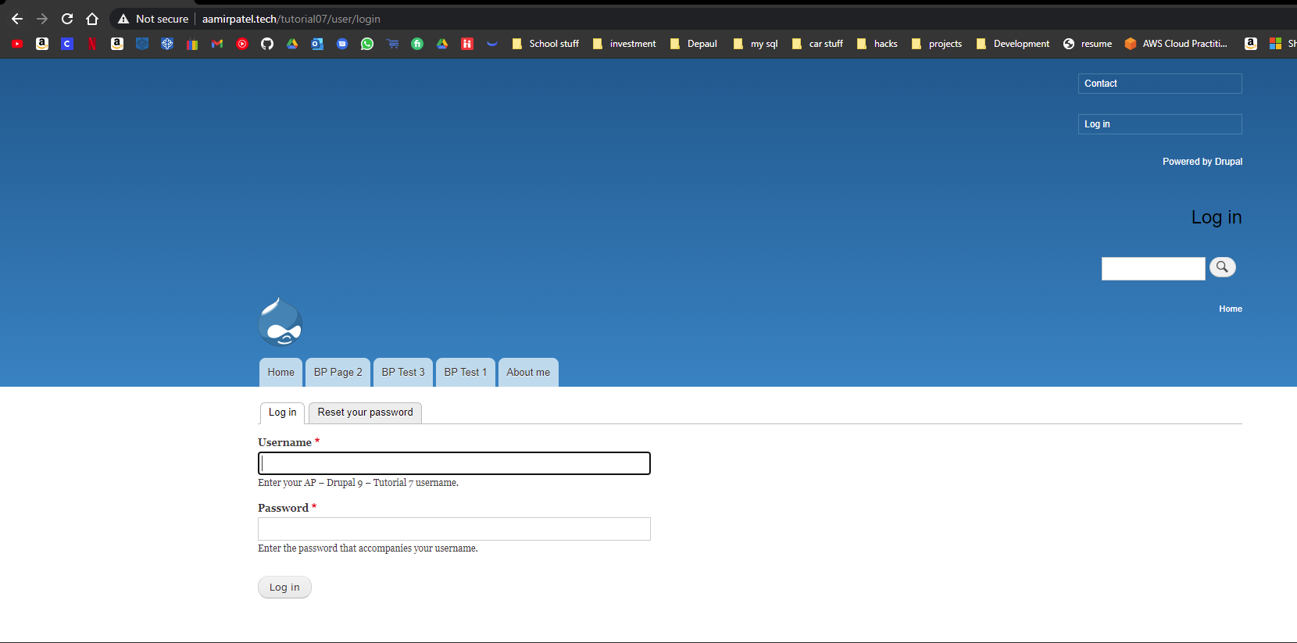 ]
3. WEBHOST SCREEN CAPTURE – Website frontend home page with web browser address bar visible.   
   [I.1.03]  
   [ 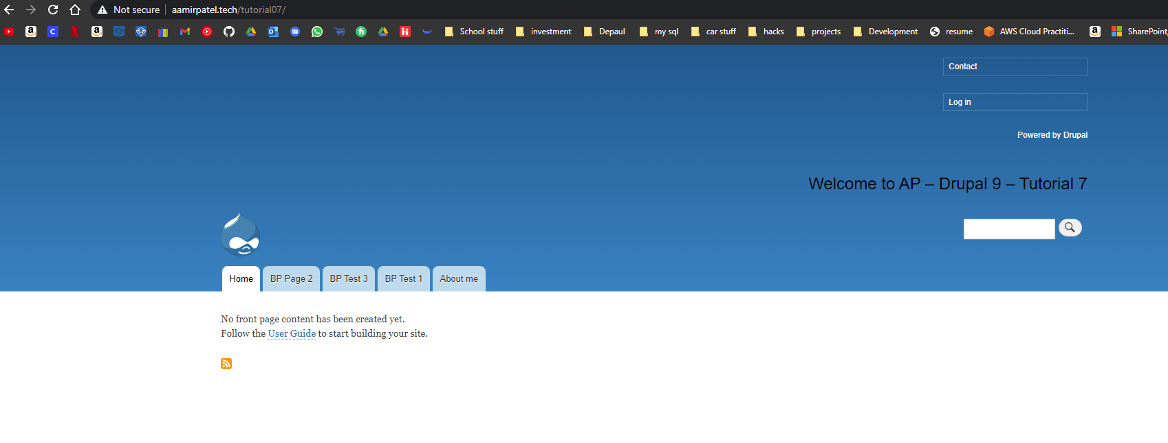 ]

Drupal On Pantheon (PaaS): (Drupal 8 or Drupal 9 )

1. Pantheon SCREEN CAPTURE – Backend Admin toolbar > Configuration > REGISTRATION AND CANCELATION >> Who can register accounts?   
   [I.2.01]  
   [BACKEND SCREEN CAPTURE HERE]
2. Pantheon SCREEN CAPTURE – Website frontend home page, then select the Login link. Please make sure the web browser address bar visible. This capture should show the login page missing the “Create new account” tab   
   [I.2.02]  
   [FRONT-END SCREEN CAPTURE HERE]
3. Pantheon SCREEN CAPTURE – Website frontend home page with web browser address bar visible.   
   [I.2.03]  
   [FRONT-END SCREEN CAPTURE HERE]

On Localhost:

1. Localhost SCREEN CAPTURE – Backend Admin toolbar > Configuration > REGISTRATION AND CANCELATION >> Who can register accounts?   
   [I.3.01]  
   [BACKEND SCREEN CAPTURE HERE]
2. Localhost SCREEN CAPTURE – Website frontend home page, then select the Login link. Please make sure the web browser address bar visible. This capture should show the login page missing the “Create new account” tab   
   [I.3.02]  
   [FRONT-END SCREEN CAPTURE HERE]
3. Localhost SCREEN CAPTURE – Website frontend home page with web browser address bar visible.   
   [I.3.03]  
   [FRONT-END SCREEN CAPTURE HERE]

On Codeanywhere:

1. Codeanywhere SCREEN CAPTURE – Backend Admin toolbar > Configuration > REGISTRATION AND CANCELATION >> Who can register accounts?   
   [I.4.01]

[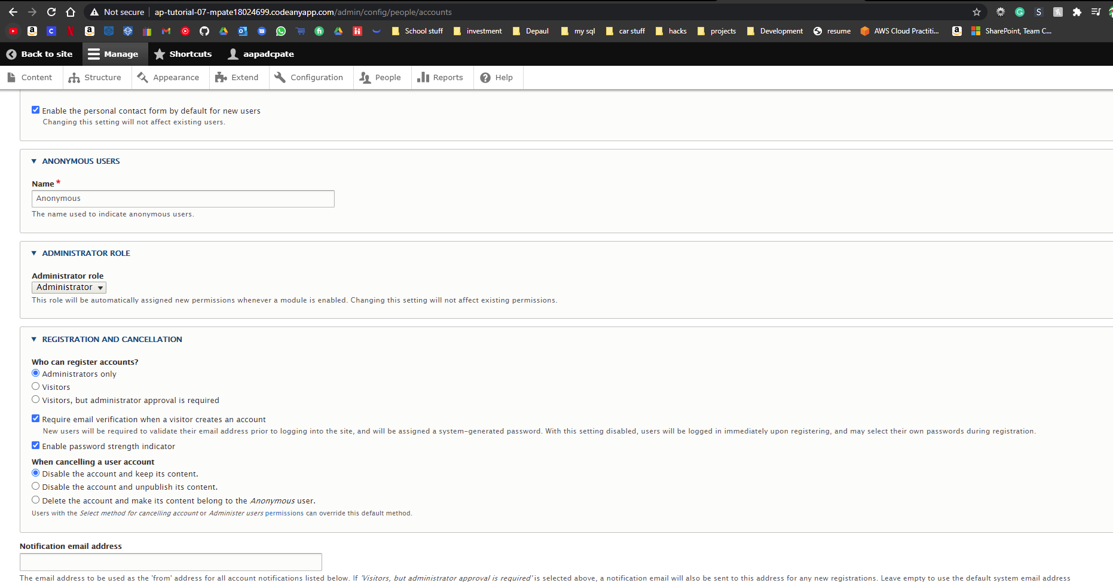]

1. Codeanywhere SCREEN CAPTURE – Website frontend home page, then select the Login link. Please make sure the web browser address bar visible. This capture should show the login page missing the “Create new account” tab   
   [I.4.02]  
   [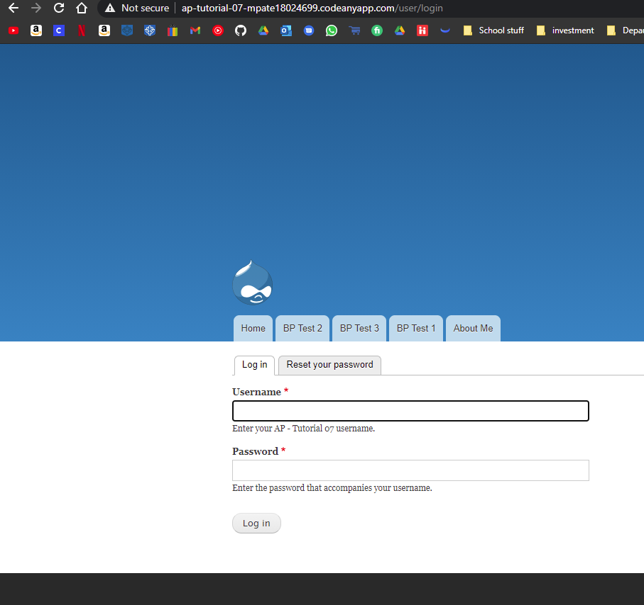]
2. Codeanywhere SCREEN CAPTURE – Website frontend home page with web browser address bar visible.   
   [I.4.03]  
   [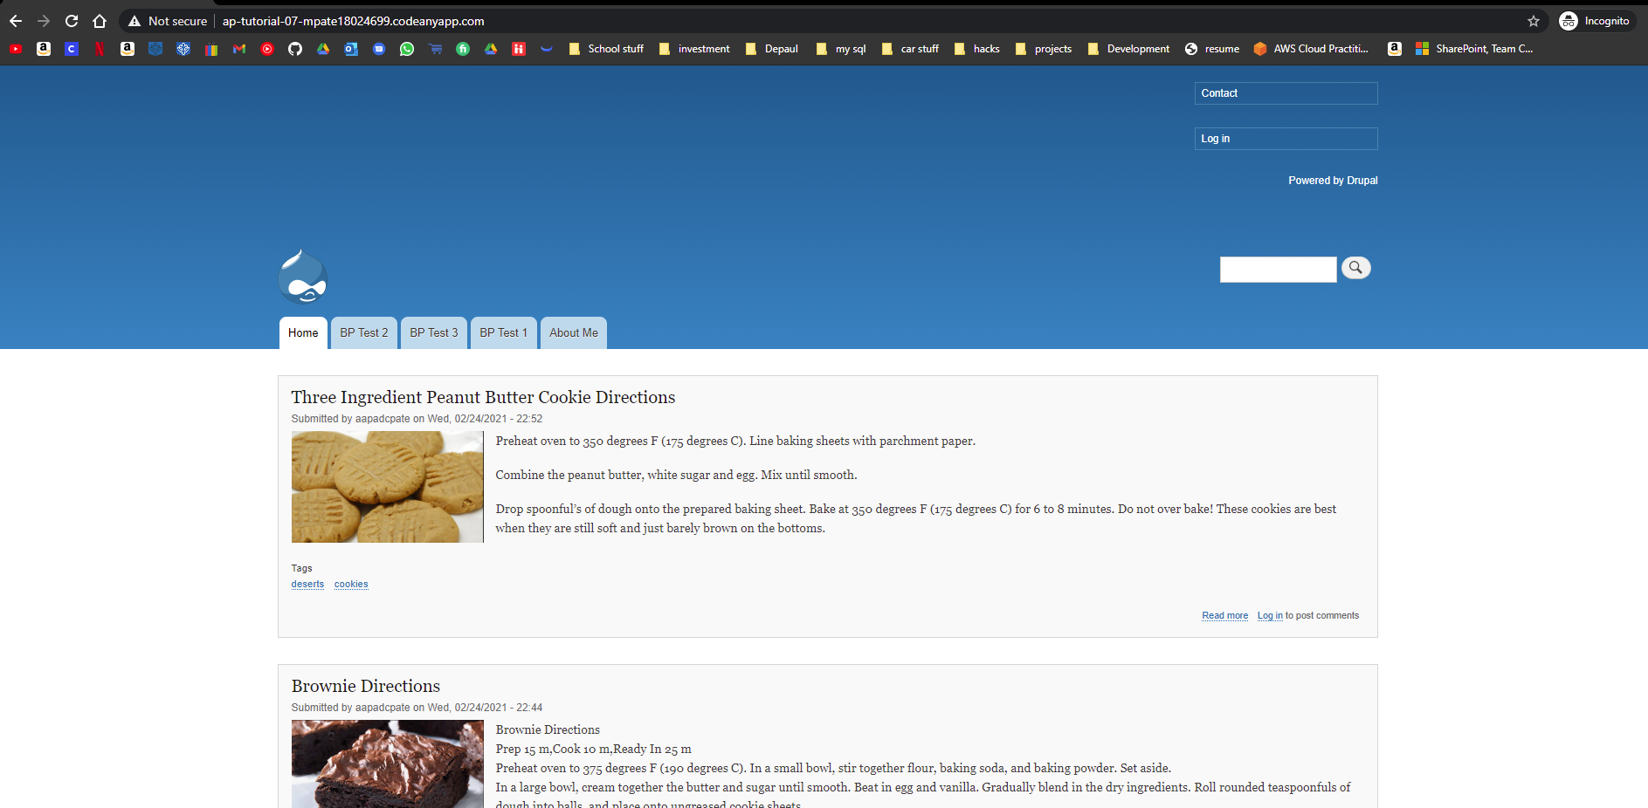]

Go back to the instructions and continue at Part J.